**Survey Questions**

Name

Age

Gender

Occupation

Location

* How good do you consider yourself to be with technology?
* What is your primary device? Phone, Laptop, or Tablet?
* Are you buying or selling?
* Are you willing to consider an online broker? Why or why not?
* Are you considering selling privately?
* What are important considerations for buying/selling? What kind of features are you looking for?
* How long have you been house searching?
* What are the first things you look for in a house?
* Is location an important factor?
* Are you a first-time home buyer? Or seller?
* Where do you see yourself in five years? Personal goals as well as career goals.
* What are your strengths and weaknesses?
* What are your hobbies/ general interests?
* How much free time do you have on average? Per day? Per week?

**Purple Bricks (UK):**

Actors – Buyers, sellers, and real estate agents

How is security addressed – book an evaluation with a local expert

Services – local real estate experts, workshops, and demonstrations. Local expert contact upon entering details to verify that you are the seller

Navigation – when hovering over buttons, different options are presented based on the actor. Easy to navigate

User input – different based on actor. Users have the option to buy or sell. Alexa compatibility to gather user input.

Tools to personalize the experience – option to interact with specialists and live agents that work for purple bricks. Depends on the comfort of the user based on experience or confidence. Novice users may not have enough knowledge thus there are options to speak with a live agent, enroll in workshops or view the FAQ section.

Organization and layout – overall the layout is free of clutter and noise. It is quite simple and easy to read. Instructions are clear and concise which the user can expand on if required.

User experience - The content is not feature-heavy and is easy for novice users while expert-focused features are hidden. This interface is designed for the intermediary users where some technical knowledge is assumed given that extra help is offered but only upon the request of the user.

**Project Stage 1: Purple Bricks/ Fair Square Analysis (Rough Draft)**

**Actors:**

* Buyer
* Seller
* No login option for Real Estate Agent visible. Realtors seem to work for Squarespace rather than being independent entities

**Services:**

1. Search bar
2. Lots of filters (Types of Properties, # of bedrooms, square footage, ect.)
3. Bar to indicate range of costs
4. Favorites
5. Featured houses have a good layout
6. Email alert system
7. Sliding scale to show how much could be saved on commission
8. Free home evaluation for buyers
9. Seems geared towards buyers – not necessarily a bad thing
10. Map extremely hard to find and not easy to use
11. Tertiary filter hard to locate
12. Too many ads – makes the screen cluttered and busy
13. Buttons on the bottom hard to locate and are a bit ambiguous (Phone number)

**Navigation:**

* Easy for prospective buyers to use – No login required, can just open the site and start searching – This also makes it seemed geared towards buyers rather than sellers (not necessarily a bad thing)
* It is not at all obvious how Real Estate agents are to use the site
* Nav bar disappears when you indicate you are a seller

**User Input:**

* **Sellers:** Name, email, phone #, sold by date, how would you like to meet with realtor?
* **Buyers:** Name, Phone#, email. Only offered phone call

**Personalization tools:**

* Favorites

**Organization and layout:**

* Poorly organized – lots of buttons are hard to find or are ambiguous
* Too many ads cluttering the screen
* Don’t like how Nav bar is always present

**User experience:**

* Lots of useful tools which could make the site very useful for users but the site is poorly designed and hard to use so the overall experience is a bad one
* Seems like buyers would have a hard time navigating to find a home they like
* Seems like most of the work is done for the seller – The real estate agent and the company seem to do most of the leg work
* Don’t know how a Real Estate agent would feel using this website

**Notes:**

* Real estate agents are not independent users of this site or at least are not made out to be. The site indicates in many places that the Realtors are employed by the company
* This is not completely commission-free but more reduced commission. This does not completely cut out the middle man, the realtor still does a lot of leg work especially for the sellers. They still Take pictures and organize viewings through the website.
* Website is very slow. If the page is refreshed it takes a long time to load – might just be my computer, but other sites are still faster on the same machine

**HTA:**

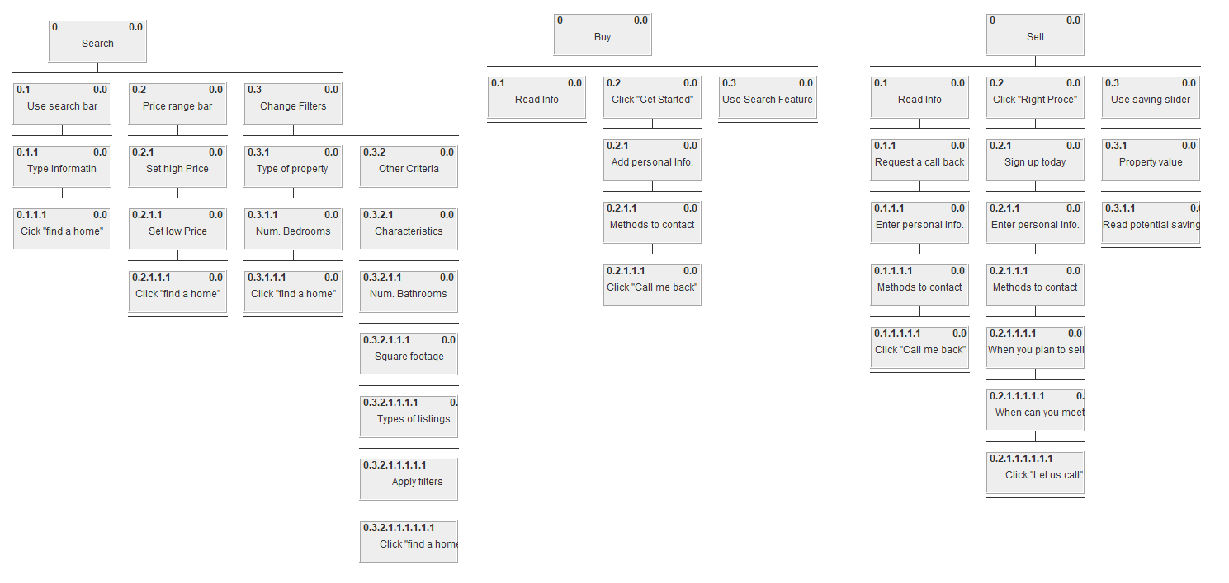

**Survey Questions:**

* Would you consider yourself proficient with technology?
* Do you preferer buying products online or in person?
* If you do prefer buying products online to in person, what are some reasons why? If you do not, why not?
* If you had to do research for a work project or school assignment, would you prefer to use resources found on the internet or visit a library? Why or why not?

Zillow

Services:

* House listings by agents or “other”
  + Can save liked listing
    - Saved homes can be compared
  + Contact an agent
  + Price, tax history
  + Neighbourhood walkability score
  + Can share listings
  + Number of views
  + View travel times to other locations
  + Lots of filters
  + 3d tour
* Sell with Zillow agent or yourself: “for-sale-by-owner” (FSBO)
* Rental listing
  + Request a tour
* New construction listings
* Zillow 360: Sell your house with a Zillow agent, find and buy house with a Zillow agent, finance with Zillow loan
* Interactive map
  + Draw area feature
  + Schools
* Loans
  + Various calculators and additional resources
* Agent Finder
* Find open houses
* Save searches
* Sellers guide blog
* Services for rental property management and advertisement

Sample pictures of looking for listings

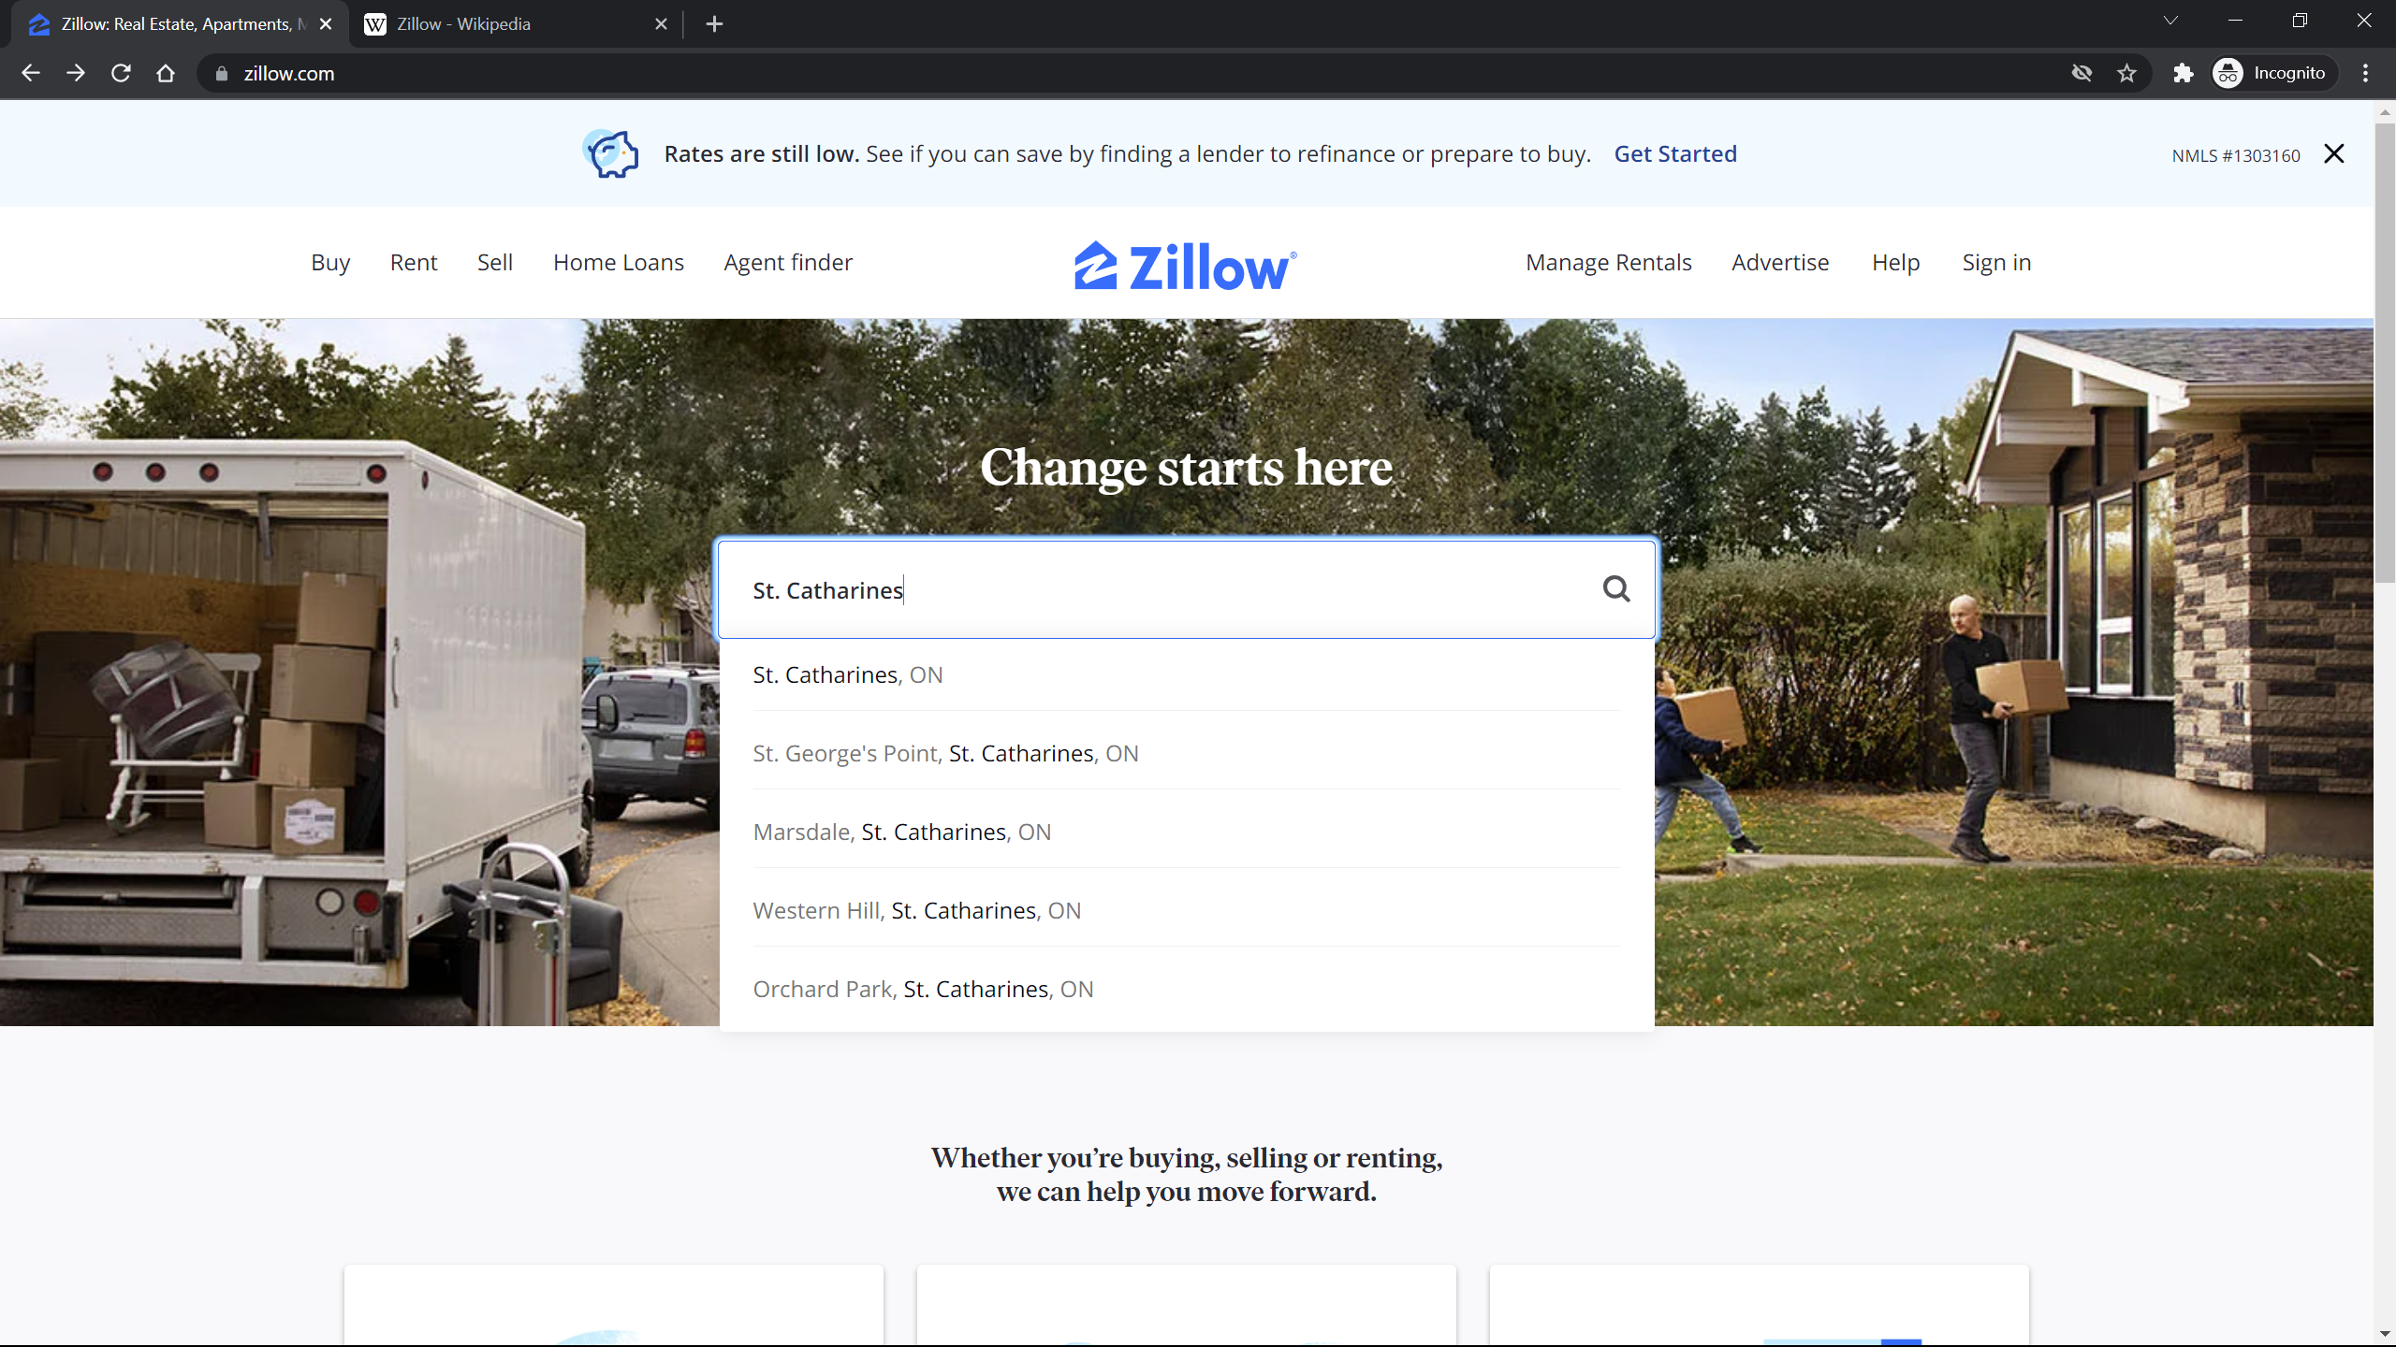 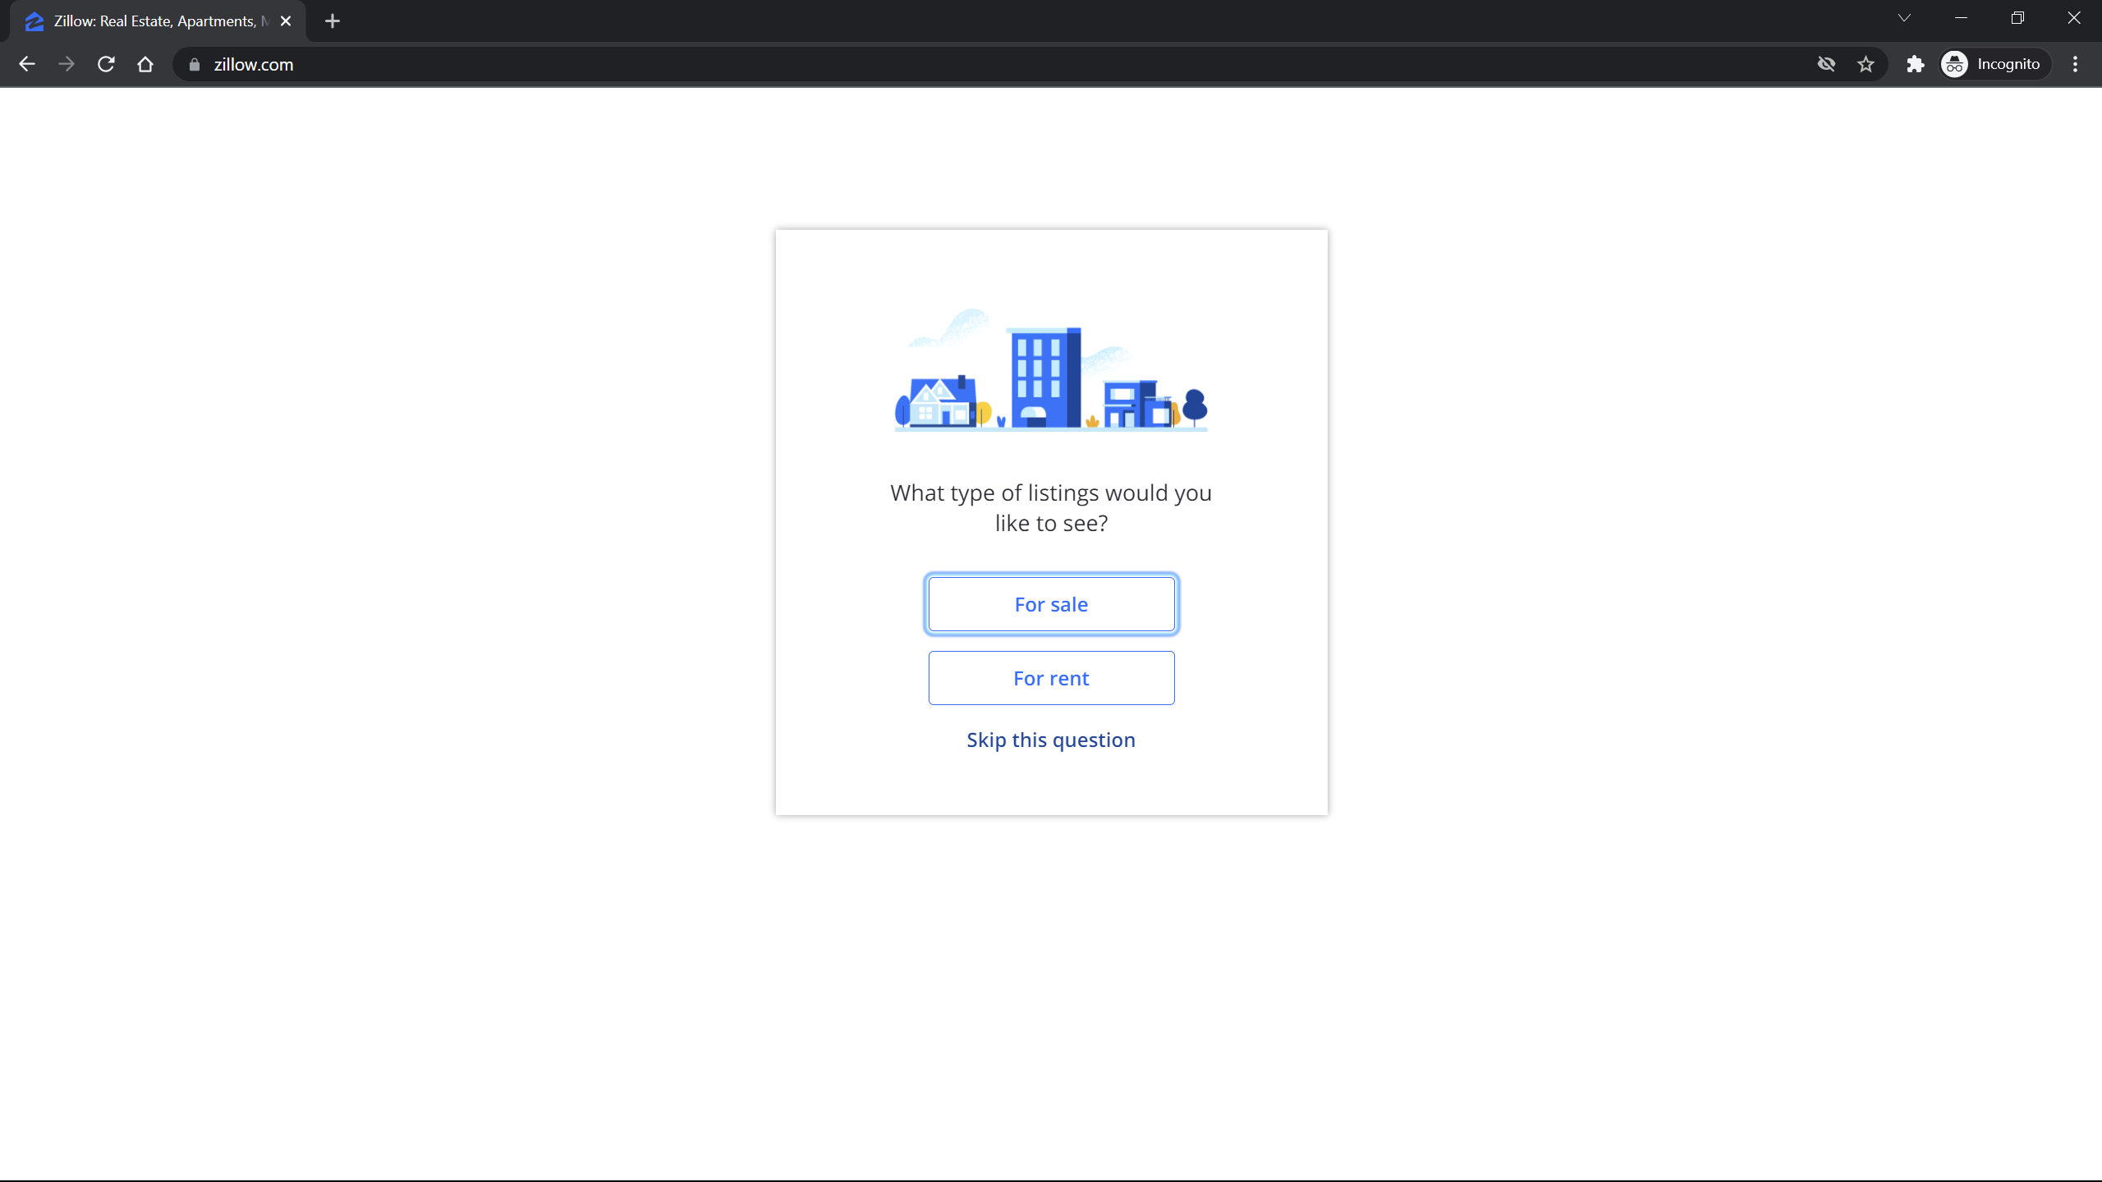

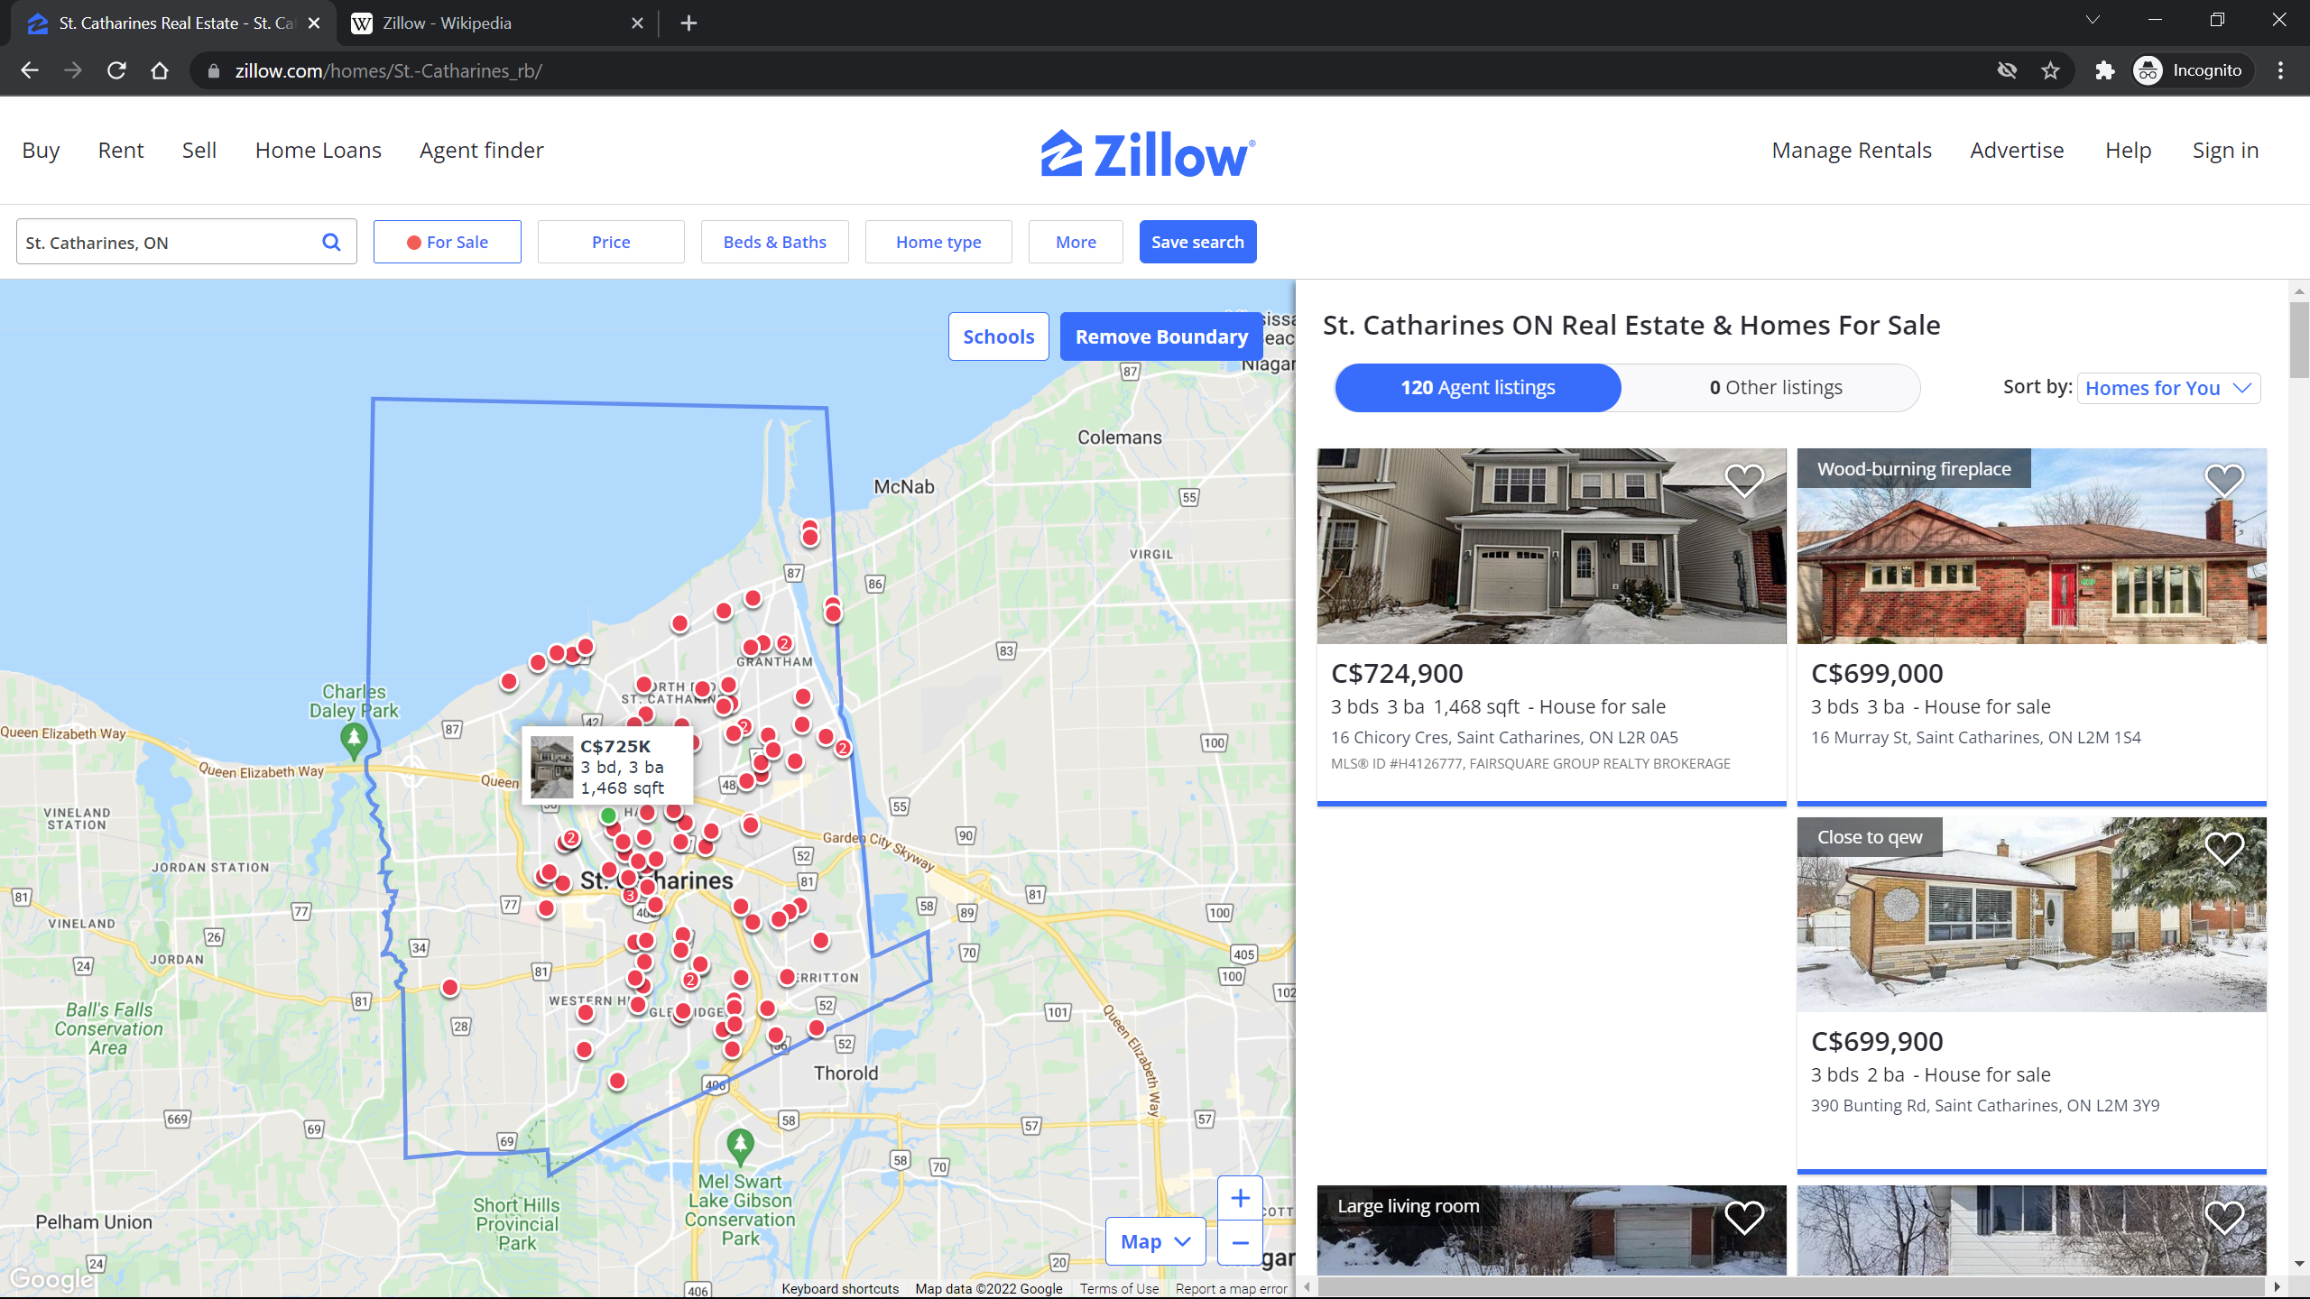 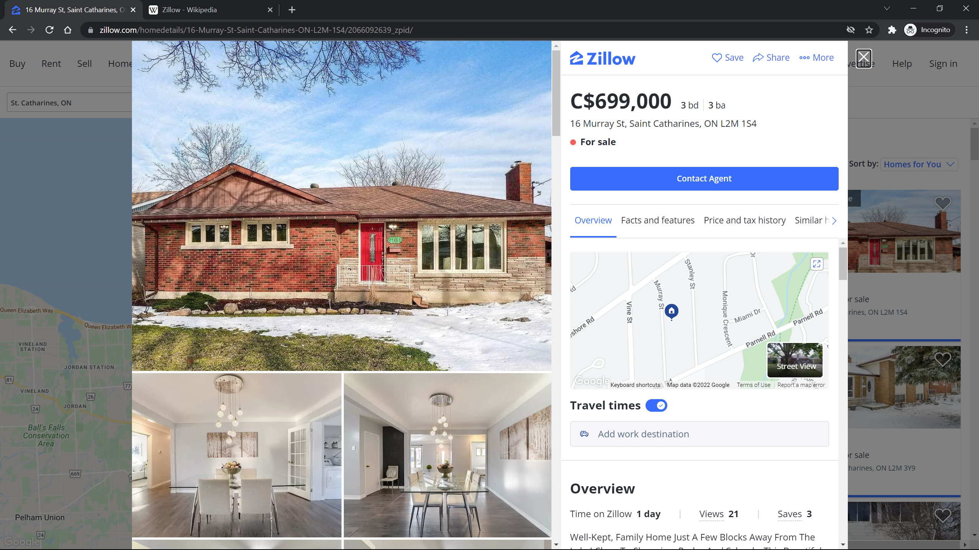

3D Tour:

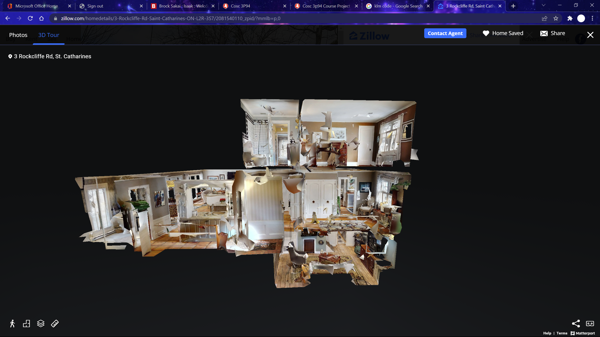

Favourites

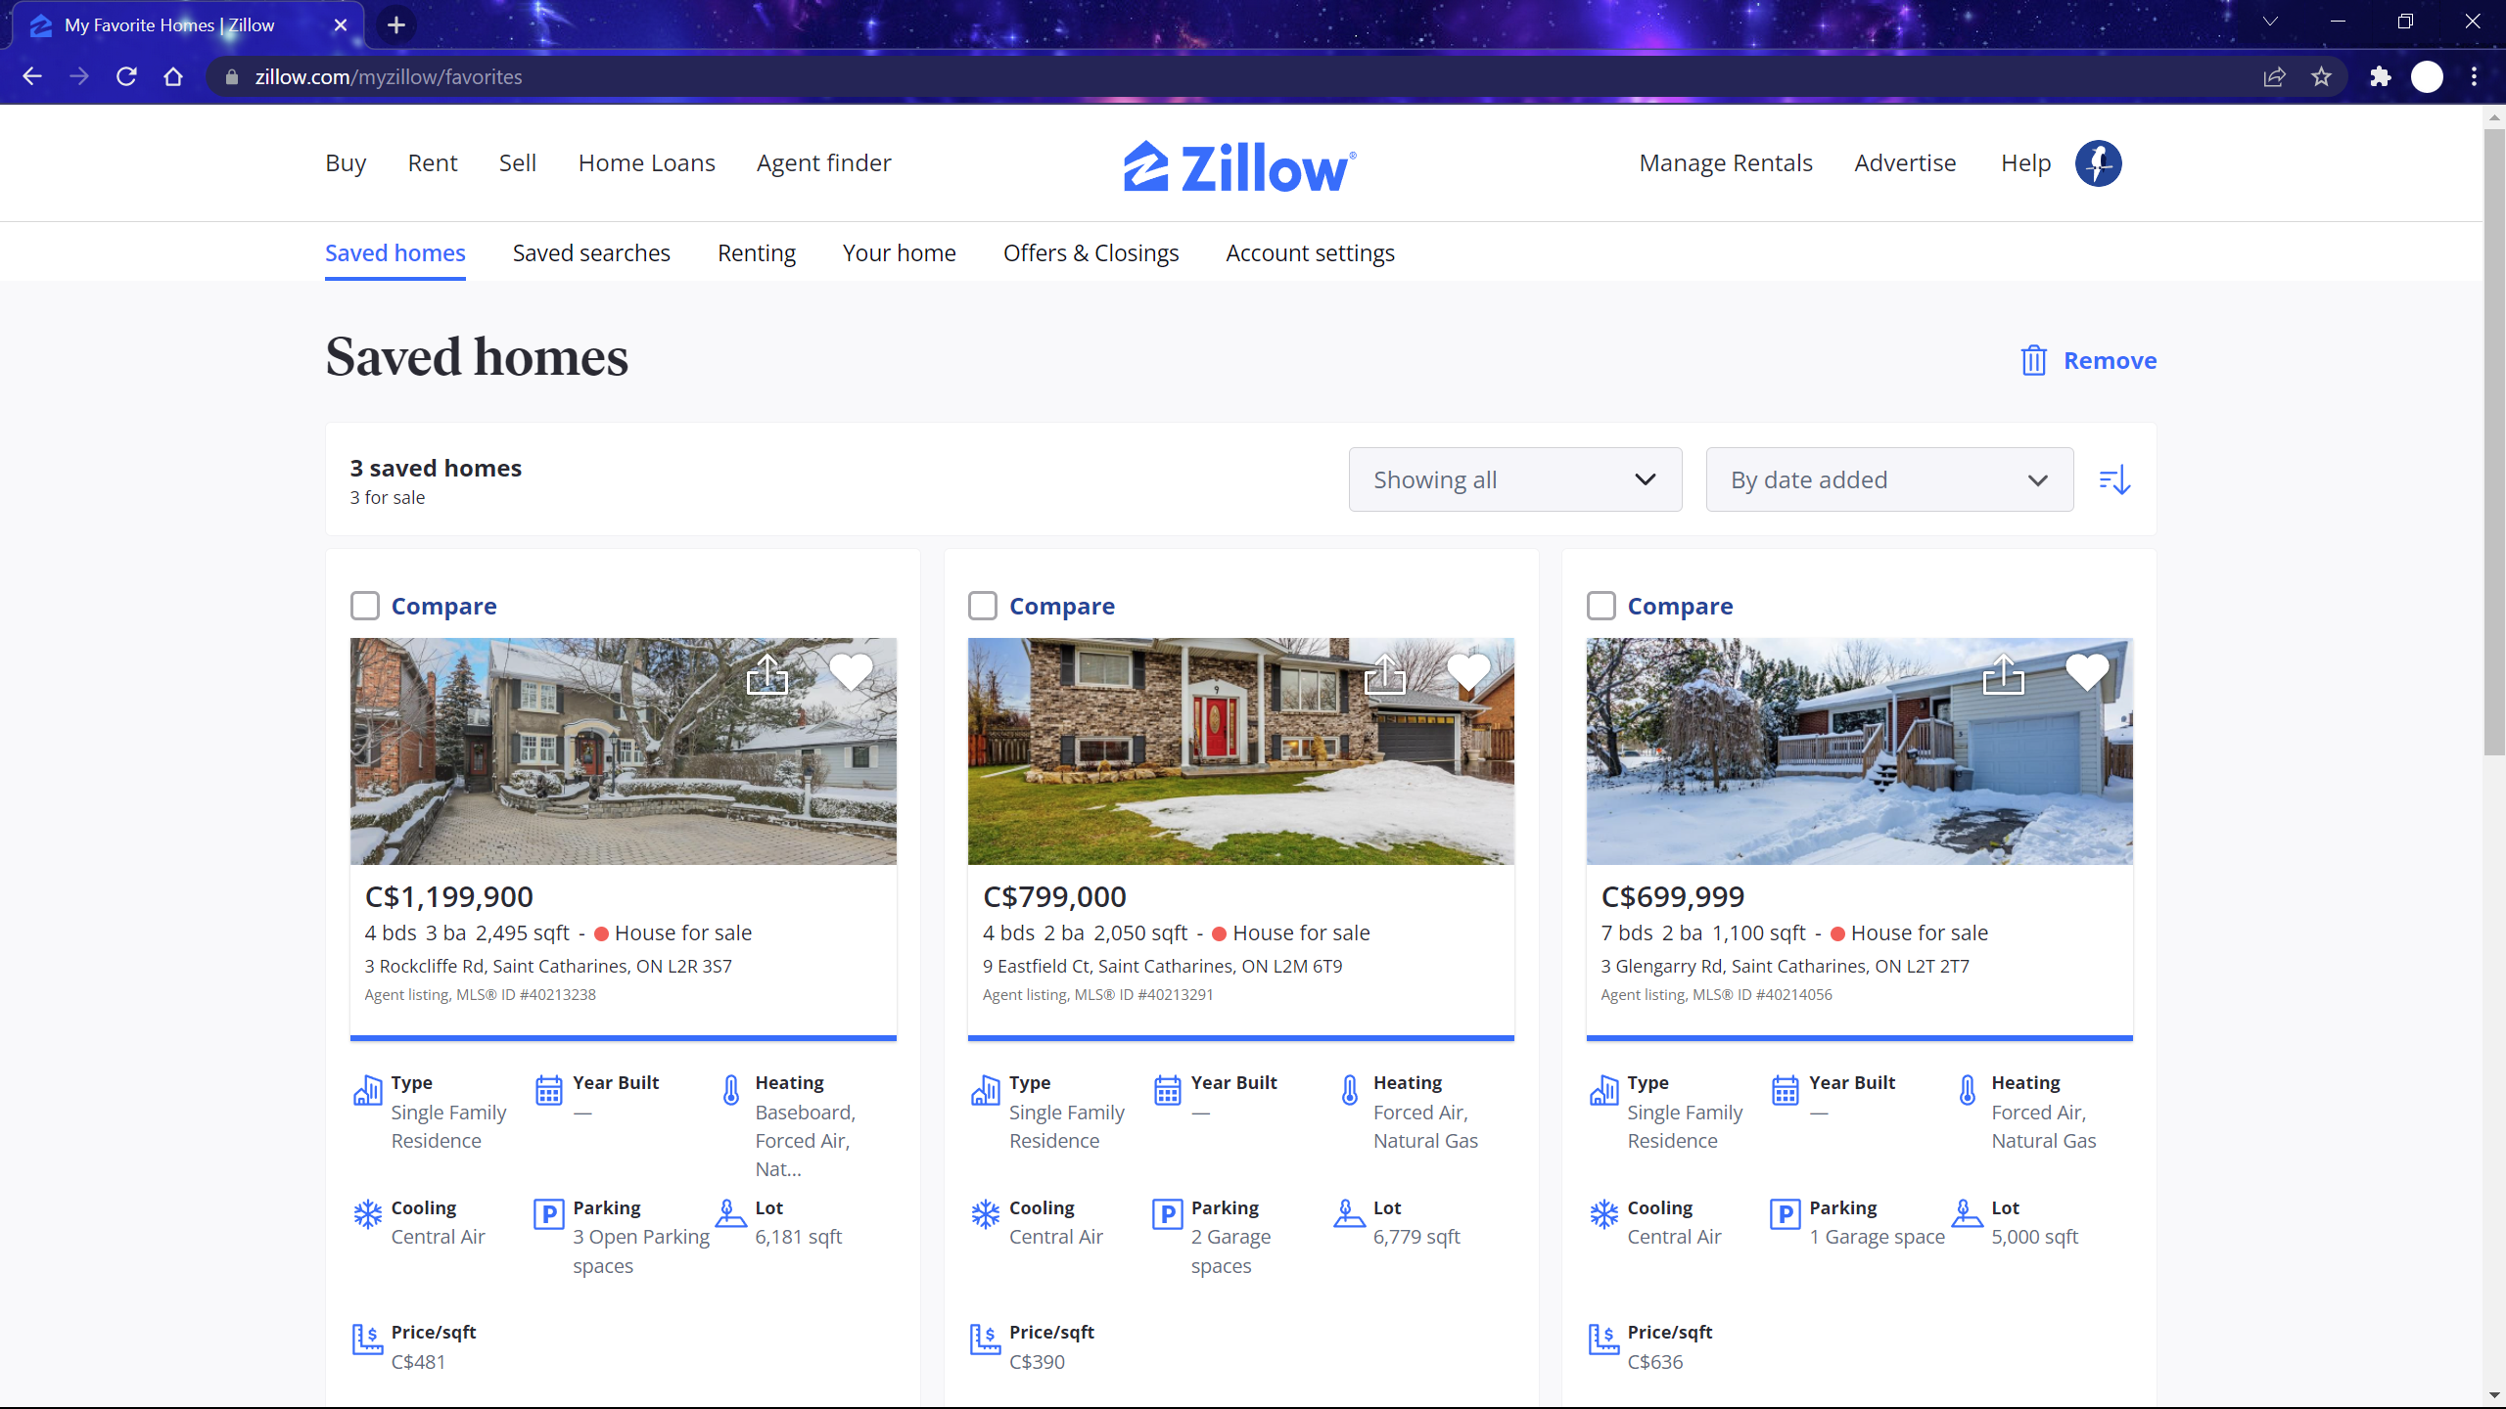

HTA

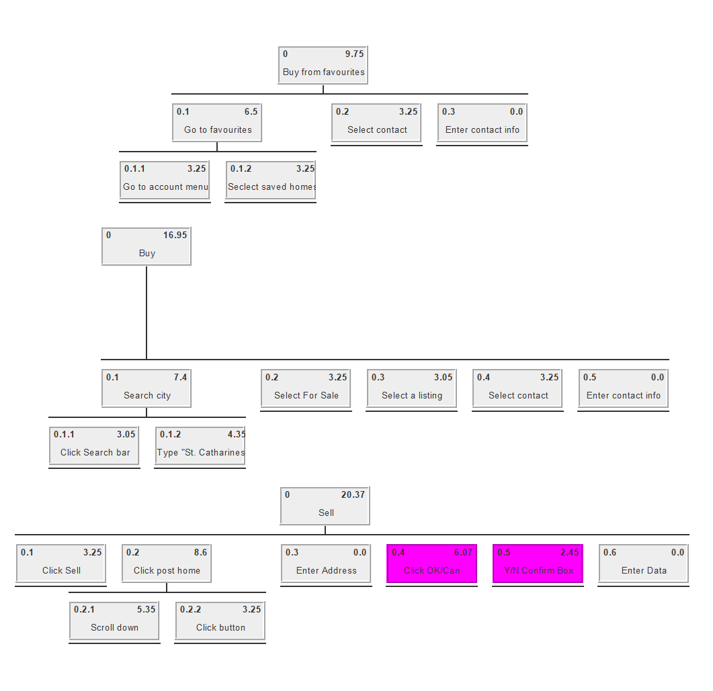

Sample HTA of uses:

Buying from a previously favorited listing

Buying from a listing

KLM: MPHK MKKKKKKKKKKKKKKS MPHKS MPHK MPHKS

Selling your home

KLM: MPHKS MR MPHKS MPHKS MPHKS

Zillow is a real estate website that allows users to buy and sell homes with the help of Zillow’s agents. It also allows for individuals to buy and sell independently without the use of a broker. It makes browsing properties for sale easy for buyers with its map-focused interface that allows you to look for houses by location. However, you can still scroll through the listings traditionally with filters to help you sort through them.

The website is easy to navigate with the menu at the top allowing you to select whether you are buying, selling, and more. The navigation menu might have more than the ideal number with nine buttons, it is not overwhelming to look at. They also have sub-menus if you hover over their respective buttons providing additional features that do not clutter the main navigation bar. Browsing the listings is easy as it provides only basic information: a picture, size, numbers of beds and baths, the address, as the relator if applicable. Though it could be argued that the realtor id is unnecessary on the list of houses as it adds more information to scroll through. For buyers, they just need to enter a city or location in the search bar and select buy and they are easily brought to the listings for that location. However, Zillow is designed for both traditional broker transactions as well as “for-sale-by-owner” (FSBO) listings. It seems to put their own brokerage services before FSBO services, and you need to scroll down the sell page to find the option and is not as simple as buyers looking at listings.

They have many helpful features to help you find your home. The simplest being the heart button allowing you to favourite listings provided you are logged in to an account. The map that was previously mentioned can also list nearby schools. Instead of searching a city, one can also circle an area on the map to search for, being flexible for the needs of the users. There are also many filters such as price, number of rooms, type of building and more. One of the more unique features of Zillow is the 3D tours, where for certain houses you can look around a 3D model of the house like a dollhouse. You can also see the various rooms inside and move around like Google Street View. The virtual tour gives you a much better understanding of the house than just regular photos. When creating your own posting, there are some helpful checks in place such as if the system believes you are entering a price that is significantly lower than what the average price is then it will give you a warning. Whether or not there are additional helpful features for sellers can’t be seen without actually submitting a listing.

Zillow’s website offers lots of tools for those in the real estate market, however, some are not as useful. Some additional features have empty sections for some locations. With the location set to St. Catharine’s, there are no foreclosures available nor are there any homes not sold by an agent. Under the agent finder where you can find various services related to buying and selling homes, there are no results for property managers, builders and more.

**User Requirements:**

**1. The role of each Actor.**

Buyer, seller, real estate agent.

**2. Security, don't want someone selling a house which does not belong to them for example.**

Must be validated before being published on site. Copy of deed?

**3. What services are presented. (think of these as content)**

Buying:

View house listings

Make offers contact seller

Map

Search/ sort filters

Hover sneak peak

Favourites list

Selling:

Provide house information

See offers/ buyer contact info

Agent:

See houses being finalized, buyer seller information.

**4.Navigation.**

Limit the amount of scrolling, menu at the top.

**5.User input. (in some cases a uses will need to provide, be active with the interface).**

Click, scrolling, keyboard to enter data. Photos of house to sell.

**6.Tools to personalize the experience.**

Favourites list, login

Dark/light modes

**7.Organization and layout**

Not too much data, keep clutter down

**8.User experience.**

Easy to use!!!

**9.Anything else which might be of use to individuals or groups.**

**10.For the purpose of this project management has requested a Web application.**

Mobile friendly webpage

Site Features

**Name:** Mark Markson

**Age:** 45

**Career:** Engineer/ Radio machine technician

**Bio:** Home owner nearly done paying off his mortgage, has a family – married with two children - and a pet cat and a new pet dog. His partner also works so they have a dual income house hold and can afford a new and better house.

**Skills:** Completed an engineering degree and works to implement and service radio technologies. Good with computers and strong maths and science skills. Got his degree in Nuclear engineering but found a job in radio technologies when he graduated and has been working there ever since.

**Motivations:** House is getting a bit cramped with all the people/ animals living in it and would like to move to a bigger home. Also does not like the location – would prefer to live in a house close to a school. Would also like to spend more time with his family – he feels he spends too much time working.

**Personal Goals:** Would like to move out of the field of radio tech and into nuclear because although he enjoys his work he feels he is overly qualified for the position, but he never has and he probably never will because he feels that he would have to take an near entry level position and he does not want to lose the seniority he has at his current company.

**Immediate Goals:** Would like a bigger house closer to a school. Is reluctant to use an online broker because he has always used an agent in the past and is not sure if he can trust a website, but his partner insisted he give it a shot and he is willing to try it as long as the website is easy to use and it saves him money.

**Frustrations:** As a person who is good with technology, he appreciates a program that is well designed and easy to use. Hates when things are more complicated than they need to be.

**Habits/Behaviours/Interests:** Plays badminton in his free time, takes his dog on walks when he can.

**Social/Tech:** Not much of a social life – spends too much time working. Proficient with technology.

**Name:** Gabbie Gabster

**Age:** 50

**Career:** Teacher

**Bio:** Home owner, has finished paying off her house and is working towards retirement. Has a partner and 3 children and a pet dog.

**Skills:** Masters in Education, excellent written and verbal communication skills as well as proficiency in math and science.

**Motivations:** Wants to retire and is looking to move into a smaller house with her partner as her children have attended or are currently attending university and have moved out.

**Personal Goals:** Would like to retire and try her hand at starting an art gallery.

**Immediate Goals:** Is open to using a online broker. Would like to use an online platform which is easy to use as she is not the best with technology.

**Frustrations:** Does not like technology and finds most applications difficult to use.

**Habits/Behaviours/Interests:** Takes long walks with her dog and enjoys painting in her free time.

**Social/Tech:** Spends most of her time working, but has a good social life. Is bad with technology.

**Name:** David Davidson

**Age:** 27

**Career:** App developer

**Bio:** Renting an apartment and lives with roommates and has a pet cat and no partner or children.

**Skills:** Masters in Software engineering, very skilled with technology and computers.

**Motivations:** Has recently received a big bonus for a project he was in charge of that was very successful and is looking to break into the housing market and purchase his first property.

**Personal Goals:** Would like to break off from his company and start making his own software independently.

**Immediate Goals:** Is open to using a online broker as he has limited funds and would like to save as much money on the commission as possible. Has never bought a house before so he is looking for a website which provides information on the buying process.

**Frustrations:** Very good with technology, and is frustrated when apps are not designed well/intuitively. He typically wants as much information as possible before he makes a big decision.

**Habits/Behaviours/Interests:** Spends most of his time working but in his free time he plays video games or watches tv.

**Social/Tech:** Not much of a social life as he is typically spending most of his time working but he does have a group of friends he plays video games with on a regular basis.